Name: _________________________________________CW#17

Reform through Cartoons:
Thomas Nast versus William “Boss” Tweed

ACTIVATOR: Read the excerpt below and categorize at least 1-2 positives and 1-2 negatives about William “Boss” Tweed by underlining positives and putting a P in the margin, and drawing a squiggly line and putting an N in the margin. [You may also use two different colored writing utensils if you wish.]

Background:
Tammany Hall was a New York City political organization that originated in the late 18th century. It became the Democratic Party’s political “machine” and thus controlled the party’s nominations. William M. Tweed, more commonly known as Boss Tweed, was a New York politician who became Tammany’s leader in the late 1860’s. As the party’s boss, he was able to appoint several city officials and essentially controlled the city government. As a result, he had access to an enormous amount of public money, which he used to enrich himself and his closest friends and allies through a variety of money laundering and profit sharing operations. It is estimated that he defrauded the city out of anywhere from $30 million to $200 million dollars (equivalent to $365 million to $2.4 billion today).
Tweed certainly had his supporters, including the large Irish immigrant population that made up his base. Under his lead, however, Tammany’s corruption was so vast and glaring – Tweed became known for wearing a large diamond in his shirtfront and lived in a mansion on Fifth Avenue – that he earned a wide range of critics. One of his most vocal critics was Thomas Nast, who featured Tweed and his cronies in many of his cartoons, particularly in 1870 and 1871.
Thomas Nast was a German immigrant who began his career illustrating newspapers and magazines, but eventually began creating political cartoons. Rising through the social and economic ranks, Nast embodied the American dream. He was a staunch advocate for municipal reform, and Tweed’s corruption fundamentally insulted his sense of equity.

Video Clip: “Boss Tweed—Thomas Nast” https://www.youtube.com/watch?v=YildL_ilQFY
DIRECTIONS: Take notes on Boss Tweed and Tammany Hall by categorizing positive and negative characteristics and actions in the T-chart below.

POSITIVE | NEGATIVE
Part 1: IMAGE ANALYSIS
DIRECTIONS: In your small groups, observe each political cartoon closely and answer the questions that follow on a separate piece of lined paper. Attach the lined paper to this packet when you are finished.

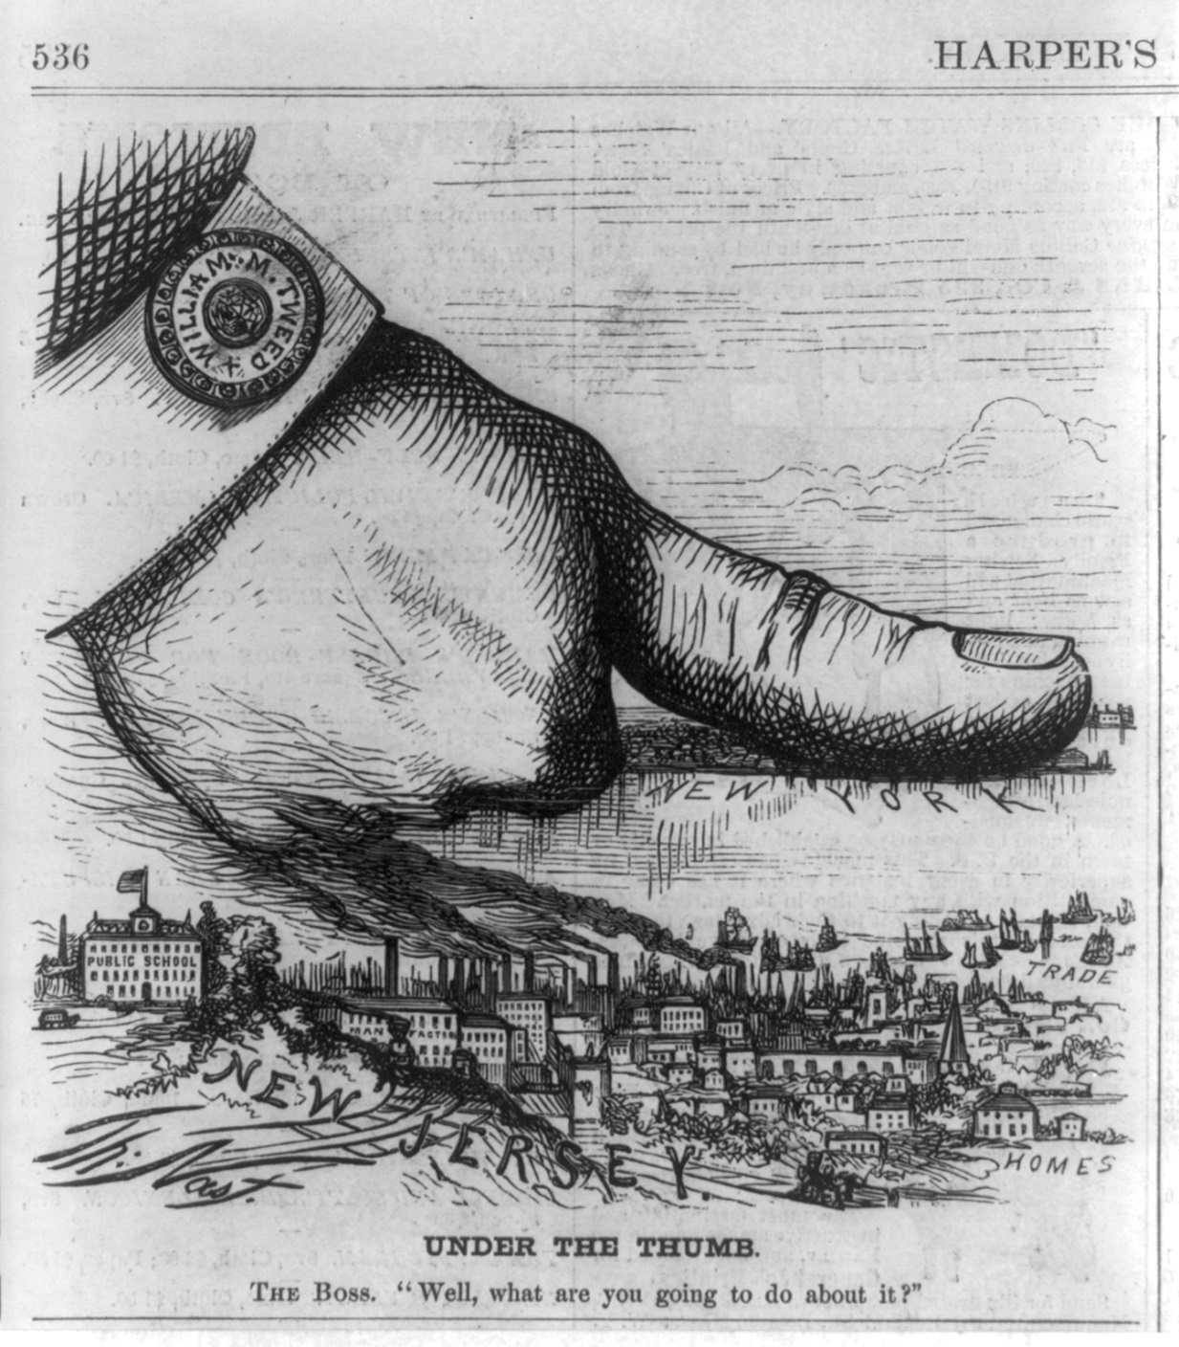
Questions to Answer:
- Whose thumb is pressing down on New York?
- Based on your answer to #1 and the image’s caption, “The Boss, “Well, what are you going to do about it?’”, what does this say about Tweed’s level of control in New York?
- How does New Jersey look in comparison to New York? Describe some of the things that are in New Jersey, according to the captions.
- In the artist’s opinion, is Tweed HELPING or HURTING New York? Explain using specific details from the image.
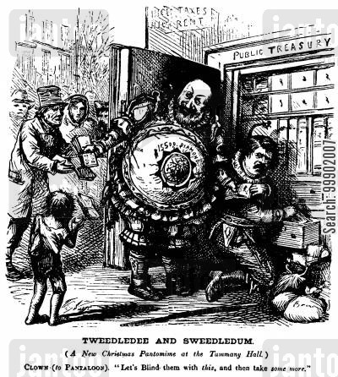

Cartoon B, “Tweedledee and Sweedledum”

Questions to Answer:
- Where are Tweed and his associate Peter Barr Sweeney (director of the Tenth National Bank, into which city money was deposited) getting money from?
- Who is Tweed giving the money to?
- The caption below the title reads, “Let’s blind them with this, and then take some more.” What does this statement mean?
- In the artist’s opinion, is Tweed HELPING or HURTING New York? Explain using specific details from the image.

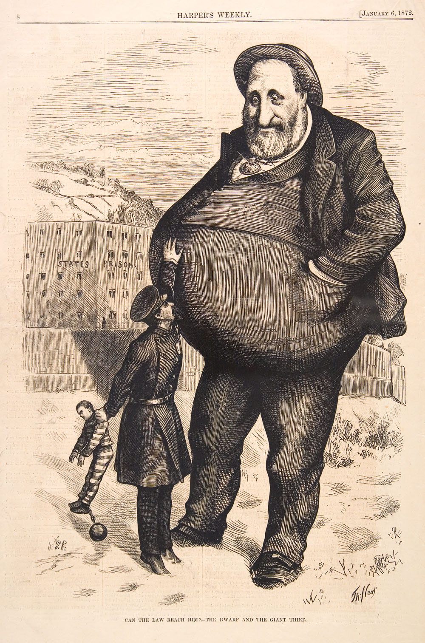

Cartoon C, “Can the Law Reach Him?—The Dwarf and the Giant Thief”

Questions to Answer:
- Based on the image, what is the policeman trying to do to Tweed?
- How does Tweed’s size compare to the prison walls, police officer, and prisoner? What does this symbolize?
- Who/what group might the smaller prisoner symbolize?
- The caption below the title reads, “Can the Law Reach Him?—The Dwarf and the Giant Thief.” What does this statement mean?
- In the artist’s opinion, is Tweed HELPING or HURTING New York? Explain using specific details from the image.

Part 2: DOCUMENT ANALYSIS
